Energy transition needs stronger power grids
Rittal and Eplan Energy Industry Dialogue: for a faster energy transition
Herborn, 2025-04-23
The energy sector is going through a period of radical change. The task now is to find out which technologies need to be utilised and which hurdles need to be overcome to restructure the electricity grid rapidly and safely. For this reason, Rittal and Eplan invited key players in the energy sector to the first Energy Industry Dialogue. The event was held on 20 March and was called “The energy transition needs stronger power grids” in the “Schalthaus” of the Grand Hall in Essen (a coal mine’s former power distribution station.)
Grid operators, integrators, component manufacturers and consultancy companies accepted the invitation to the Energy Industry Dialogue. Experts from the power grid industry used the event for an intensive exchange of ideas about visions, challenges and building blocks for a future-proof grid.
The speakers at the Industry Dialogue presented a variety of solutions and examples of implementation, with a focus on digitalisation, standardisation and automation. From the manufacture of components and switchgear to the operation and maintenance of the systems, they represent the most effective levers for transforming the sector, ensuring energy security, while meeting climate targets at the same time. If the energy transition is to succeed, these levers must be used to rapidly expand and restructure the energy sector, a gigantic task given the complexity of the electricity grid. Skilled labour shortages, supply bottlenecks, and high cost pressures further complicate matters. It is time to identify the building blocks that make up the energy transition.

The German electricity grid: 1.9 million kilometres long and with 800 grid operators
The complexity of the topic quickly became clear as Stephanie Kudak, Vertical Market Manager at Eplan, described the current state of the power grids: they cover 1.9 million kilometres in Germany and are run by 800 network operators. Around 500,000 transformers must be manufactured and installed by 2045 to create a bidirectional grid. This is a complex task that, along with the levers mentioned above, also requires businesses to make a cultural change, as industrial engineers Svenja Eger and Stefan Vlachakis from Capgemini demonstrated in an informative presentation.

The panel discussion on “Electricity grids in the focus of digitalisation” rounded off the morning. Representatives of Hamburger Energienetze (the Hamburg power grids), the Technical University of Dortmund and TenneT described their experience with digitalisation projects. Bendic Ritt, Hamburger Energienetze, presented the “gridlytics” platform, which links up the grid, metering and customer stations, control systems, BIM models and master data management systems. As one example, Rittal showed how circuit diagrams created with Eplan solutions can be exported to the platform and used again there. One exciting research project at the Technical University of Dortmund addressed the way that market and grid simulations can help achieve grid flexibility.

Building blocks of the energy transition: market players in dialogue
In a second panel discussion held during the afternoon, JST Power Equipment, Hitachi Energy, Microsoft and Eplan identified the building blocks of the energy transition and discussed concrete implementation models. Gerrit Helms, Vertical Market Manager Energy at Eplan, presented the “Eplan Project”, an ecosystem through which component manufacturers, operators, switchgear manufacturers and system integrators can exchange their data with each other, so enabling the planning and operation of everything from wind farms to substations. The topics of the panel presentation by Daniel Schenzer and Philippe Gnand from Microsoft were predictive analytics and maintenance, energy forecasting and smart grids. They described impressively how network operators can use AI for tasks ranging from planning to maintenance.
The contributions to the discussion showed the range of potential of the available technologies and the existing hurdles. At the end of the day, the organisers and participants agreed that the Herculean task of the energy transition could only be achieved at an appropriate pace through dialogue.

Trade fair information: Interested parties can find out which solutions Eplan and Rittal offer for the rapid conversion of energy systems at the SmarterE trade show, being held from 5 to 7 May 2025 in Munich, and at CIRED from 16 May to 19 June 2025 in Geneva.
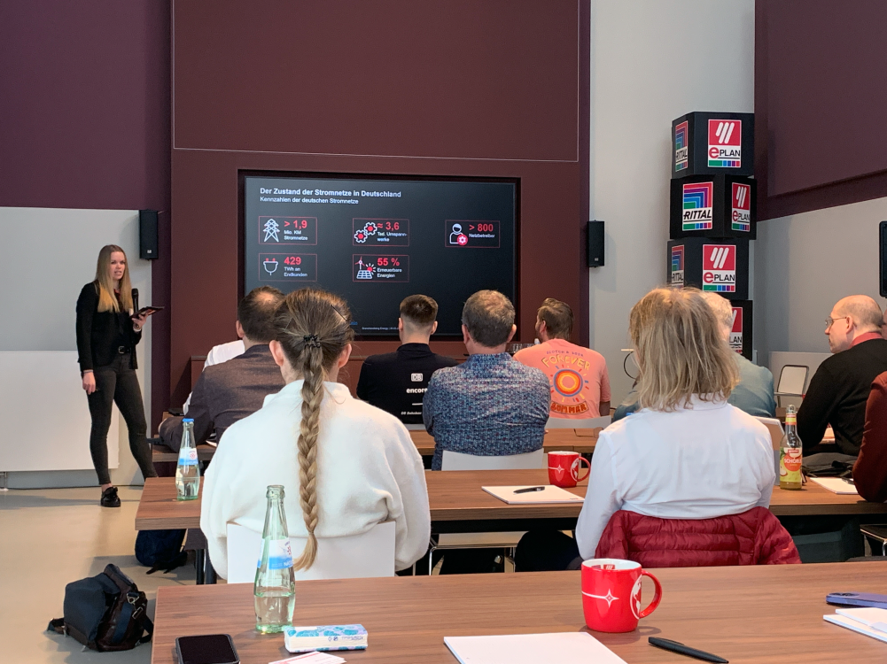 |  | 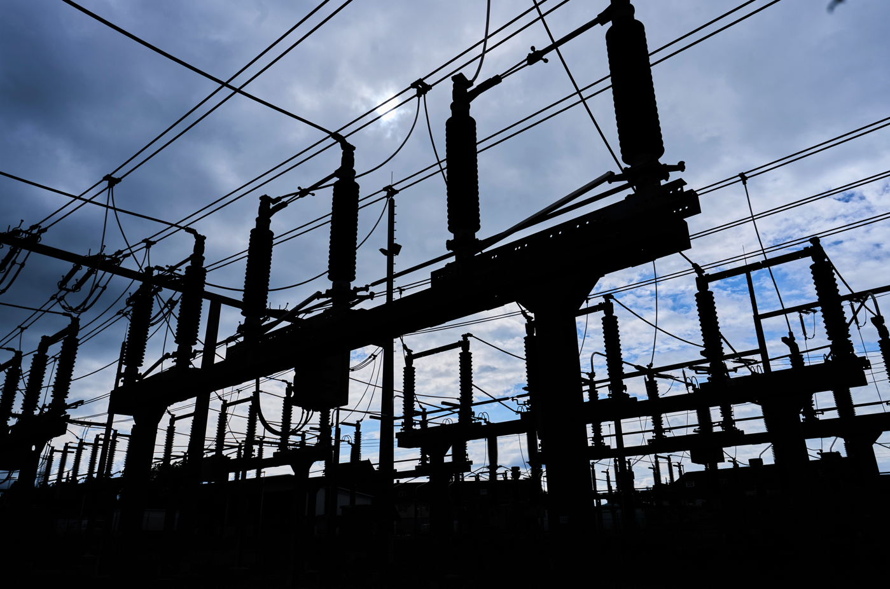
Image 1:  Eplan_Rittal_Branchendialog_Energy.jpg |  | Image 2:  Stromnetze_naturenergie netze.jpg  Der Energiesektor ist im Umbruch. Jetzt gilt es auszuloten, welche Technologien eingesetzt und welche Hürden überwunden werden müssen, um einen schnellen und sicheren Umbau des Stromnetzes zu erreichen.
The Energy Industry Dialogue event was held on 20 March and was called “The energy transition needs stronger power grids” in the “Schalthaus” of the Grand Hall in Essen (a coal mine’s former power distribution station.)

Rittal

Rittal is a leading global supplier of enclosure systems, automation and infrastructure with its industrial, IT, energy and power, cooling and service units. Rittal products and solutions are used in over 90% of global industries – standardised, customised, and always of the very best quality.
Our approach and methodology: With their combined hardware and software expertise, Rittal, Rittal Software Systems (Eplan and Cideon) and Rittal Automation Systems (RAS, Ehrt, Alfra) optimize, digitize and automate processes along the entire customer value chain, including the IT infrastructure – from panel building and switchgear manufacturing to mechanical engineering, factory operators and the energy sector.
Our delivery promise: Rittal standard products are delivered in Germany within 24 hours, and within 48 hours throughout Europe.
Customer focus
Improving efficiency and increasing productivity through automation and digitalisation is one of the biggest challenges for our customers. This requires in-depth knowledge and expertise, the combination of hardware and software, and cross-sector networking. We are convinced that creating and connecting data rooms is crucial to the success of industrial transformation. And that is exactly our speciality and field of competence.
Eplan and Rittal are driving the development of the digital automation twin, making data accessible and useable in operations as well. Cideon is improving data consistency in the digital product twin context with its CAD/CAM, PDM/PLM and product configuration expertise.
Sustainability
Environmental and climate protection, social commitment and ethical corporate management are a given for Rittal. We take our responsibility for a sustainable future seriously. Our approach to resource management and conservation involves continuous improvement of our own production processes and ensuring that our products have the lowest possible Product Carbon Footprint. Our solutions support our customers in achieving their own climate targets.
Family business and global player
Founded in 1961, Rittal is the largest company in the owner-operated Friedhelm Loh Group. The group operates worldwide, with 12 production sites and 95 international subsidiaries. It has 12,100 employees and posted revenues of 3 billion euros in fiscal 2023. In 2023, the Friedhelm Loh Group was presented with the “Best Place to Learn” and “Employer of the Future” awards. In 2024, Rittal was awarded the Top 100 Seal as one of Germany’s most innovative medium-sized companies for the third time in a row.
For more information, visit www.rittal.com and www.friedhelm-loh-group.com.

Corporate Communications
Dr. Carola Hilbrand Rittal GmbH & Co. KG
Corporate & Brand Communications Auf dem Stützelberg
Phone: 02772/505-2527 35745 Herborn
hilbrand.c@rittal.de www.rittal.com

Eplan

Eplan provides design, planning and engineering software and service solutions for all aspects of electrical, automation and mechatronic engineering. The company has developed one of the world’s leading design software solutions for machine and panel builders. Eplan is also the ideal partner to simplify and streamline complex and challenging engineering processes.
Both standardised, as well as customer-specific interfaces to ERP and PLM/PDM systems, ensure data consistency across the entire value chain. Working with Eplan means seamless communication across all engineering disciplines. Regardless of whether the company is large or small: It allows customers to use their expertise more efficiently. Worldwide, Eplan serves and supports 68,000 customers. Together with its customers and partners, Eplan strives to continue growing and actively advancing integration and automation in engineering. Within the Eplan Partner Network, open interfaces and seamless integrations are implemented together with partners. “Efficient engineering” is Eplan’s core focus.
Eplan was founded in 1984 and is part of the owner-operated Friedhelm Loh Group. The group operates worldwide, with 12 production sites and 95 international subsidiaries. It has 12,100 employees and posted revenues of 3 billion euros in fiscal 2023. In 2023, the Friedhelm Loh Group was presented with the “Best Place to Learn” and “Employer of the Future” awards.
For more information, visit www.eplan-software.com and www.friedhelm-loh-group.com.

Corporate Communications
Birgit Hagelschuer Eplan GmbH & Co. KG
Press- and public relations An der alten Ziegelei 2
Phone: 02173 3964-180 40789 Monheim am Rhein
Hagelschuer.b@eplan.de www.eplan.com

